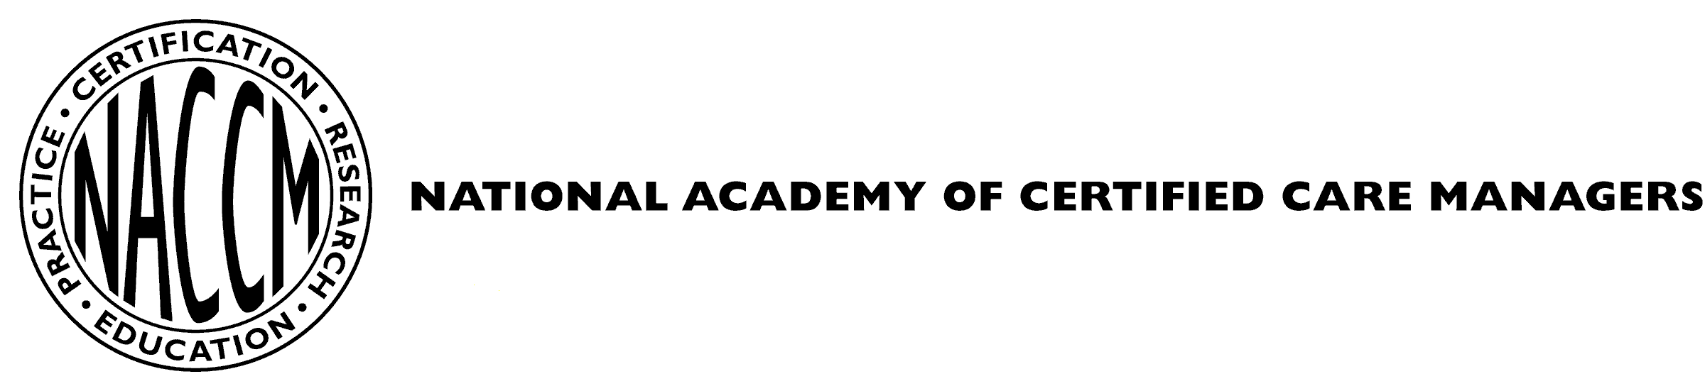

CMC RENEWAL FORM

This form must be completed and returned to the National Academy of Certified Care Managers with the completed Continuing Education Summary Form and the renewal fee(s).

Please print clearly or type in the form fields.
Current Cert. Dates: |  | Certificate #
CMC Name |  | CMC Email
CMC Work Phone |  | Alt Phone
CMC Home Address
Employer |  | Position/Title
Dates of Employment
Employer Address
Are you a current member of the Aging Life Care Association® (ALCA)? Yes No
Are you currently employed in the field of Care Management? Yes No
Have you been employed in the field of Care Management during this certification period?
Yes No Comments:

Description of Responsibilities:
- Indicate the role(s) you perform as a care manager:
Direct Care Management (as defined in renewal handbook)
Care Manager Consultation/Supervision (as a leader or participant)
Administrator/Supervisor of Care Management Program/Practice
Consultant to Care Management Programs/Agencies or Educator (program development, supervision, quality assurance, CM training, etc.)

- Check the content domains that include the care management functions performed related to the role(s) listed above (check all that apply).
Domain I. Assess and identify client strengths, needs, concerns, and preferences
Domain II. Establish goals and a plan of care
Domain III. Implement care plan
Domain IV. Manage and monitor the ongoing provision of and need for care
Domain V. Ensure professional practice and supervision of care management

Supervision/Consultation:

While NACCM does not require a specific number of hours per year of professional supervision/ consultation, ongoing participation is required for certification renewal.

I participated in regular professional consultation/supervision with my clinical supervisor and/or peers during my certification period. Yes No

Attestation to accurate reporting:
By submitting this form, I hereby attest that:

all information provided to NACCM, including attachments, are accurate, truthful, and complete, and;

I have not engaged in any misconduct that would support the revocation of my certification as set forth in the NACCM Revocation of Certification Policies and Procedures, and;

I have read and agree to adhere to the Aging Life Care Association® Standards of Practice and Code of Ethics at aginglifecare.org

I understand that it is my responsibility to maintain appropriate documentation which verifies the stated practice, continuing education, and consultation/supervision.

NACCM, at its sole discretion, has the right to audit this documentation. I understand that false or misleading information on this form, whether by inclusion or omission, will result in the revocation of certification.

Signature |  | Date
(Electronic signature is acceptable.)
CMC Renewal Form 2019

